CSE 3241 Project Checkpoint 02 – Relational Model and Relational Algebra
Names: Om Kurkure, Cole Taglione, Mitchell Zahner, Sayan Bisi Date: 2/15/2025

In a NEATLY TYPED document, provide the following:
- Provide a current version of your ER Model as per Project Checkpoint 01. If you were instructed to change the model for Project Checkpoint 01, make sure you use the revised version of your ER Model.
Link: https://lucid.app/lucidchart/42289468-aeb6-4772-bf85-f07177cde7ba/edit?invitationId=inv_cdd269a0-a869-4f17-8e61-94d5317e468d
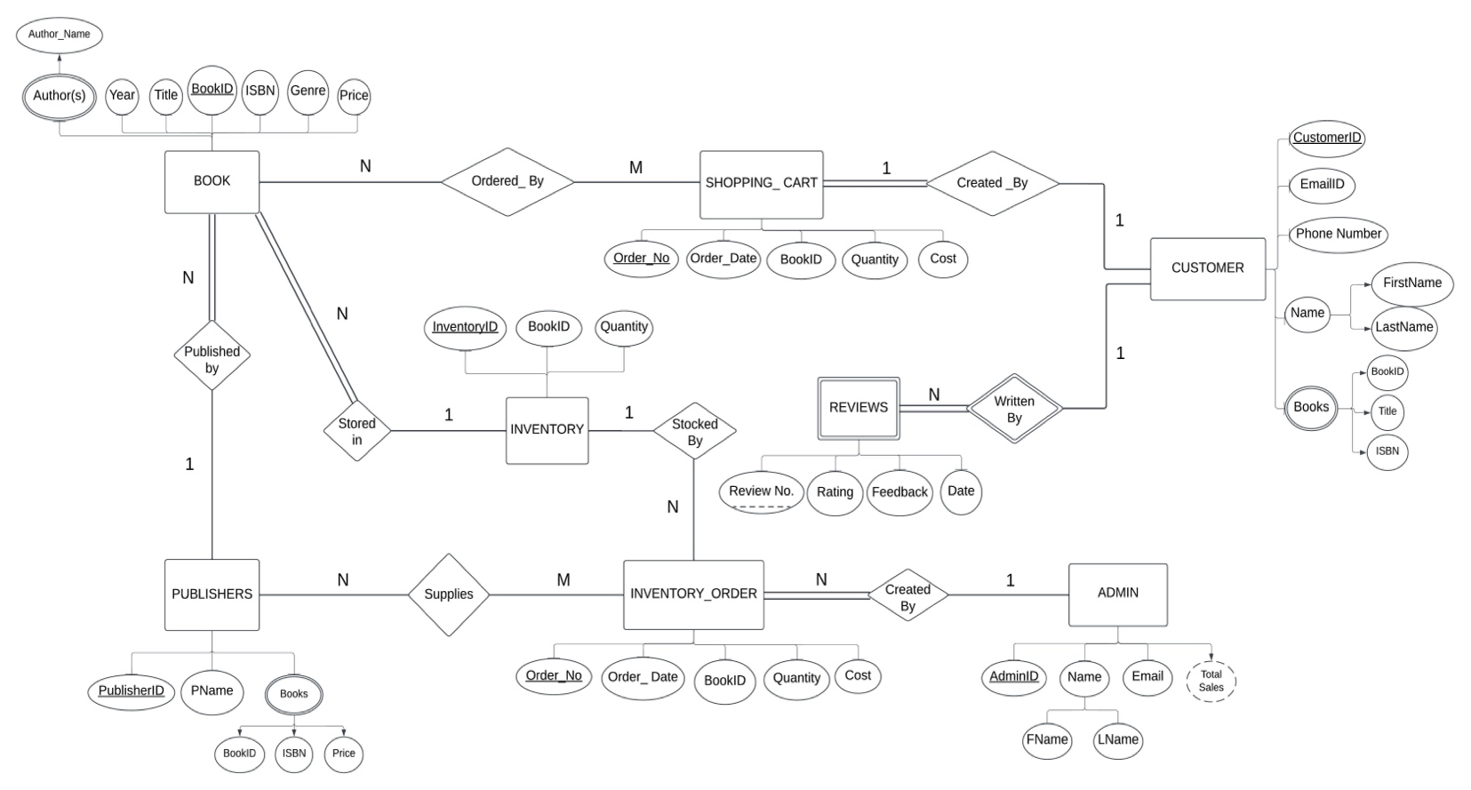

- Map your ER model to a relational schema. Indicate all primary and foreign keys.
ADMIN(AdminID#, FirstName, LastName, Email)
INVENTORY_ORDER(Order_No#, Order_Date, InventoryID^{(FK)}, AdminID^{(FK)}, BookID^{(FK)}, Quantity, Cost)
BOOK(BookID#, PublisherID^{(FK)}, InventoryID^{(FK)}, Title, Year, Genre, ISBN, Price)
ORDERED_BY(Order_No#, BookID^{(FK)})
PUBLISHERS(PublisherID#, PName)
SUPPLIES(Order_No#, PublisherID^{(FK)}, Rating, Feedback, Date)
AUTHOR(BookID#^{(FK)}, Author_Name)
INVENTORY(InventoryID#, BookID^{(FK)}, Quantity)
CUSTOMER(CustomerID#, FirstName, LastName, Email, Phone_Number)
SHOPPING_CART(Order_No#, Order_Date, CustomerID^{(FK)}, BookID^{(FK)}, Quantity, Cost)
REVIEW(Review_No#, CustomerID^{(FK)}, Rating, Feedback, Date)
CUSTOMER_BOOKS(CustomerID#^{(FK)}, BookID#^{(FK)}, Title, ISBN)
PUBLISHER_BOOKS(PublisherID#^{(FK)}, BookID#^{(FK)}, ISBN, Price)
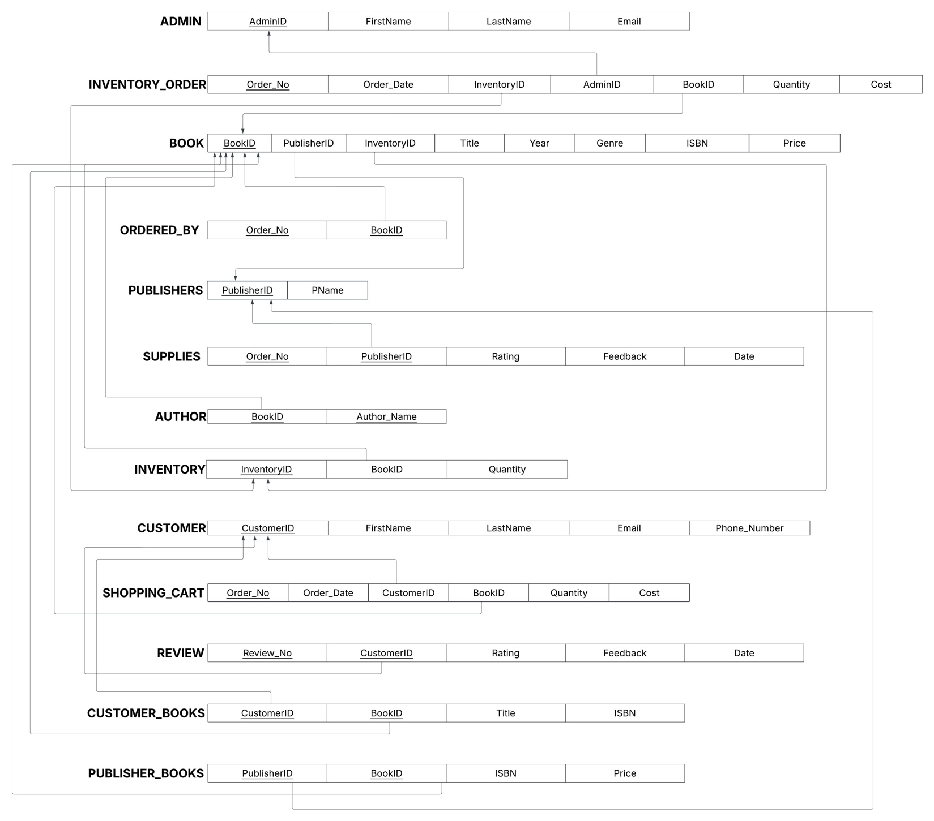
- Given your relational schema, provide the relational algebra to perform the following queries. If your schema cannot provide answers to these queries, revise your ER Model and your relational schema to contain the appropriate information for these queries:
  - Find the titles of all books by Pratchett that cost less than $10
PRATCHETT_ID π _{BookID} (σ _{Author_Name = ‘Pratchett’} (AUTHOR))
BOOKS PRATCHETT_ID ⋈ PRATCHETT_ID.BookID = BOOK.BookID (BOOK)
RESULT π _{Title} (σ _{Price < 10} (BOOKS))

  - Give all the titles and their dates of purchase made by a single customer (Assumption CustomerID = 100)
BOOK_TITLES π _{BookID,Title} (σ _{CustomerID = 100} (CUSTOMER_BOOKS))
CUSTOMER_ORDERS σ _{CustomerID = 100} (SHOPPING_CART)
PURCHASE_DATES BOOK_TITLES ⋈ BOOK_TITLES.BookID = SHOPPING_CART.BookID (CUSTOMER_ORDERS)
RESULT π _{Title, Order_Date} (PURCHASE_DATES)

  - Find the titles and ISBNs for all books with less than 5 copies in stock
LOW_BOOK_IDS π _{BookID} (σ _{Quantity < 5} (INVENTORY))
BOOKS LOW_BOOK_IDS ⋈ LOW_BOOK_IDS.BookID = BOOK.BookID (BOOK)
RESULT π _{Title, ISBN} (BOOKS)

  - Give all the customers who purchased a book by Pratchett and the titles of Pratchett books they purchased
PRATCHETT_BOOK_IDS π _{BookID} (σ _{Author_Name = ‘Pratchett’} (AUTHOR))
PRATCHETT_CUST PRATCHETT_BOOK_IDS ⋈PRATCHETT_BOOK_IDS.BookID = CUSTOMER_BOOKS.BookID (CUSTOMER_BOOKS)
CUSTOMERS_ENHANCED PRATCHETT_CUST ⋈ PRATCHETT_CUST.CustomerID= CUSTOMER.CustomerID (CUSTOMER)
RESULT π CustomerID, FirstName, LastName, Title (CUSTOMERS_ENHANCED)

  - Find the total number of books purchased by a single customer (Assumption CustomerID = 100)
CUSTOMER_BOOK_COUNT _{CustomerID} ℑ _{COUNT BookID} (CUSTOMER_BOOKS)
RESULT σ _{CustomerID = 100} (CUSTOMERS_BOOK_COUNT)

  - Find the customer who has purchased the most books and the total number of books they have purchased
ρBOOK_COUNT(CustomerID, BookCount) (_{CustomerID} ℑ _{COUNT BookID} (CUSTOMER_BOOKS))
ρMAX_COUNT (CustomerID, NumBooks) (_{CustomerID} ℑ _{MAX BookCount} (BOOK_COUNT))
RESULT ß π CustomerID, FirstName, LastName, NumBooks (MAX_COUNT ⋈ MAX_COUNT.CustomerID = CUSTOMER.CustomerID (CUSTOMER))

- Come up with three additional interesting queries that your database can provide. Give what the queries are supposed to retrieve in plain English and then as relational algebra. Your queries should include joins and at least one should include an aggregate function. At least one of your queries should use “extra” entities you added to your model in Checkpoint 01.
  - Find count of ratings per Customer and average rating per Customer along with Customer name and email
ρREVIEW_PER_CUST(CustomerID, NumReview, AvgRating) (_{CustomerID} ℑ _{COUNT ReviewNo, AVERAGE Rating} (REVIEWS))
CUSTOMER_DETAILS REVIEW PER_CUST⋈ REVIEW_PER_CUST.CustomerID = CUSTOMER.CustomerID (CUSTOMER)
RESULT π CustomerID, FirstName, LastName, NumReview, AvgRating (CUSTOMER_DETAILS)

  - Find all stock orders made for books by ‘Pratchett’ and retrieve admin details, date of order, quantity, and cost
PRATCHETT_BOOK_IDS π _{BookID} (σ _{Author_Name = Pratchett} (AUTHOR))
PRATCHETT_ORDERS PRATCHETT_BOOK_IDS ⋈ PRATCHETT_BOOK_IDS.BookID = INVENTORY_ORDER.BookID (INVENTORY_ORDER)
ADMIN_DETAILS PRATCHETT_ORDERS ⋈ PRATCHETT_ORDERS.AdminID = ADMIN.AdminID (ADMIN)
RESULT π AdminID, FName, LName, Order_Date, Quantity, Cost (ADMIN_DETAILS)

  - Find all publishers for books authored by ‘Pratchett’ along with book tiltles and price
PRATCHETT_BOOK_IDS π _{BookID} (σ _{Author_Name = ‘Pratchett’} (AUTHOR))
PRATCHETT_BOOKS π BookID, PublisherID, Title, Price (PRATCHETT_BOOKS_IDS ⋈ PRATCHETT_BOOK_IDS.BookID = BOOK.BookID (BOOK))
PRATCHETT_PUB PRATCHETT_BOOKS ⋈ PRATCHETT_BOOKS.PublisherID = PUBLISHER_BOOKS.PublisherID (PUBLISHERS)
RESULT π PublisherID, PName, Title, Price (PRATCHETT_PUB)

